Einstein
Business Science and Technology Centre
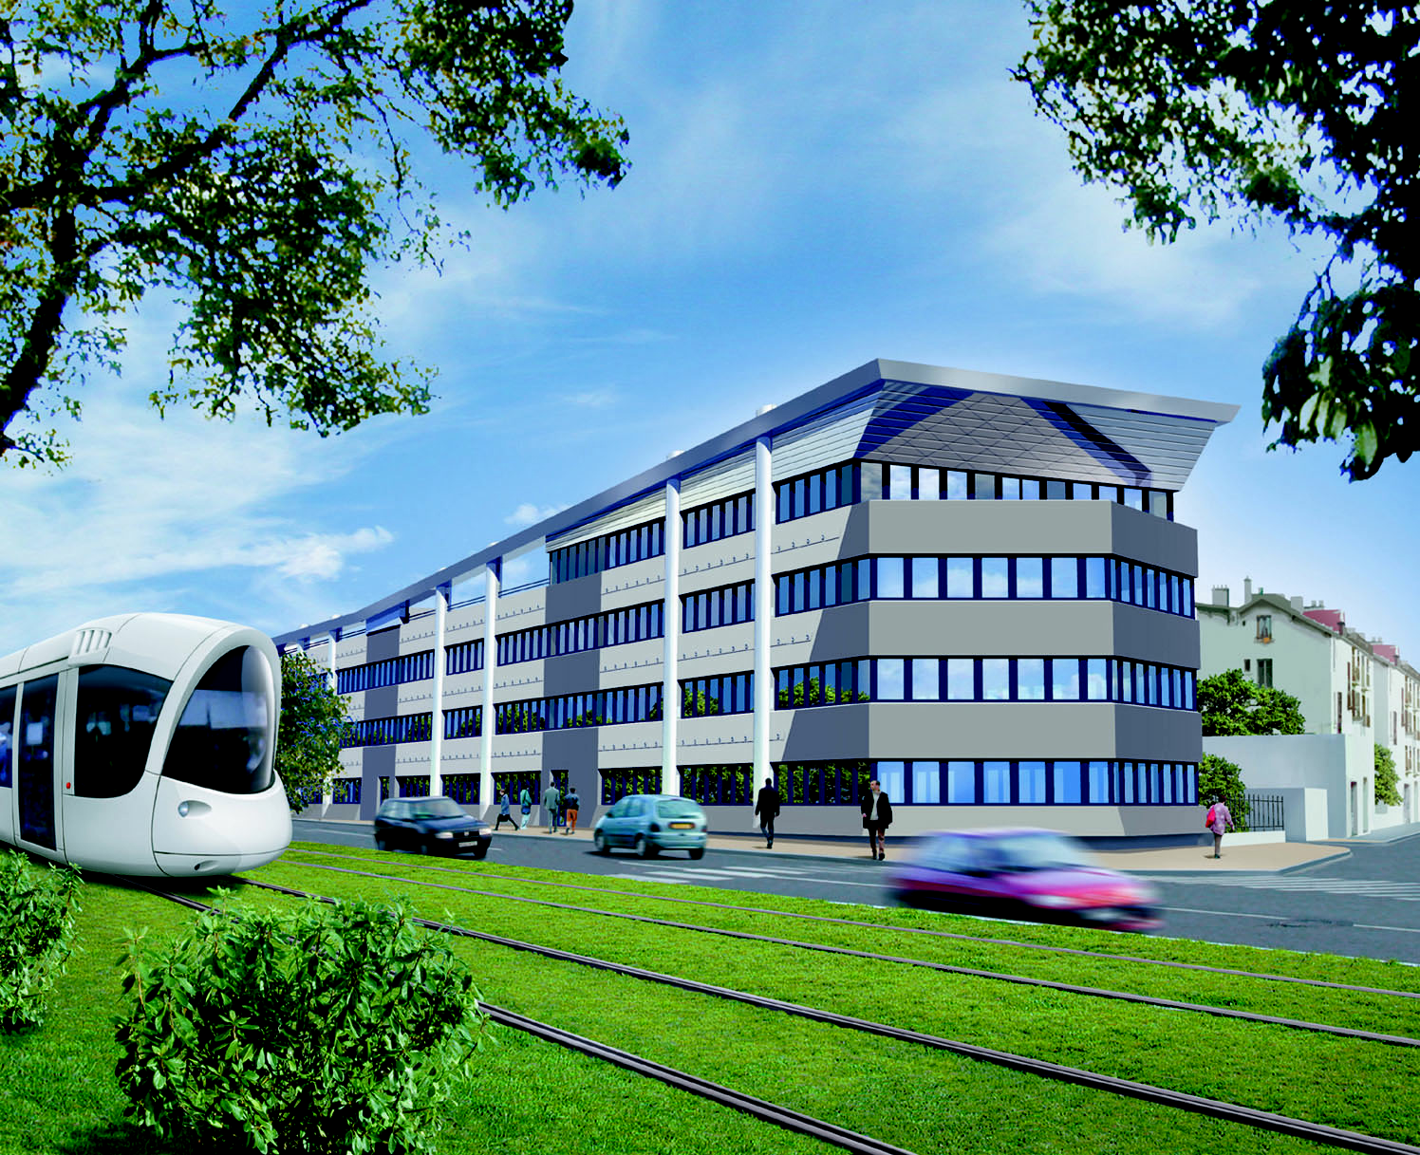

strategic property possibilities

Einstein, the Centre for Business Science and Technology is part of Greater Lyon's high-tech business zone strategy. The strategy is aimed at reinforcing and promoting the conurbation's image and potential in the fields of research, innovation and the new technologies.

EINSTEIN is an economic development property project situated on the La Doua Scientific Estate, one of the strategy's major sites.

a programme committed to innovation

EINSTEIN has been created to accommodate creators, pioneers, start-ups and innovative and high-tech companies
• cultivating emerging professions
• or involved in fields of research represented in the La Doua Science Park

EINSTEIN's siting, architecture and functioning have been specially chosen with the new economic actors in mind.

EINSTEIN lends itself perfectly to the installation of systems of information, exchange, partnership and capacity-building, working with all the conurbation's high-tech actors in the science and business fields.

easy to get to

EINSTEIN is linked to the centre of Lyon by the new conurbation tramway:
• direct connection to the Lyon Part-Dieu high-speed train station

EINSTEIN is linked to France's largest cities and the European motorway network by the ring road, 300 metres away:
• direct motorway access: A6 (Paris), A7 (Marseille-Nice), A42 (Geneva) and A43 (Chambéry-Grenoble)

EINSTEIN is 25 minutes from the Lyon Saint-Exupéry international airport.

EINSTEIN enjoys an agreeable setting close to the Tête d'Or Park and the planned Feyssine Park.

EINSTEIN is situated in a neighbourhood amply provided with sporting facilities, hotels and restaurants.

EINSTEIN is close to the Cité Internationale and its Convention Centre.

To get to Einstein, take the tram to the INSA EINSTEIN stop (Line T1).

a multi-purpose rental building

EINSTEIN is designed to accommodate offices or laboratories

Some EINSTEIN statistics:
• 1 building built in 2 phases
• Phase 1 ready June 2001
• 2400m2 usable floor area
• 4 levels
• units from 210 to 360m2
• units divisible from 50m2
• 2 internal lifts
• 34 basement parking spaces, remote-control access
• access by badge at main entrance and for each floor
• shared service areas

advanced techniques for high technology

EINSTEIN is an ultra-modern building specifically designed to meet multiple technical demands.

• heat pump heating and cooling system, using ceiling distribution cassettes with individual remote control.
• soundproofed windows and suspended ceilings.
• wiring for individual units transits via external baseboards. Floor-recessed multi-plugs in central area (levels 1-3).
• separate lighting systems with remote control adjustment.
• vertical external sheathes, with provision for installation of special equipment (cold water, additional ventilation, etc).
• prewired for telephone and computers (free choice of operator).

a resource centre

EINSTEIN offers resident businesses top of the line services:

• mail service
• instant phone connection for technical maintenance
• card-access reprography facilities
• fully equipped relaxation room and smoking area
• terrace with outdoor furniture
• meeting room for hire, equipment provided

EINSTEIN
11-13 Avenue Albert Einstein – 69100 Villeurbanne

Marketing : SERL - Anne-Marie Merle

Tel. (++ 33 0)4 72 61 50 50 Fax (++ 33 0)4 26 84 05 09
e-mail: am.merle@serl.fr

